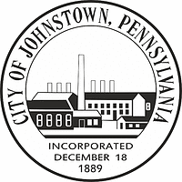**CITY OF JOHNSTOWN**

**City Council**

Frank Janakovic, Mayor

Rev. Sylvia King Deputy Mayor

Charles Arnone

Ricky Britt

Laura Huchel

Taylor Clark

Marie Mock

**WORKSHOP AGENDA**

**ANTHONY C. TRUSCELLO**

**COUNCIL CHAMBERS**

**WEDNESDAY, MAY 14, 2025**

**5:00 P.M.**

CALL TO ORDER:

INVOCATION:

PLEDGE OF ALLEGIANCE:

PUBLIC COMMENT: (Limit 5 minutes)

WORKSHOP ITEMS:

1. Parking Application Changes
2. Central Park Updates

ADJOURNMENT: