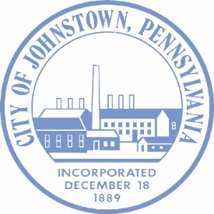
CITY OF JOHNSTOWN

City of Johnstown Comprehensive Plan Survey Invitation
Dear Johnstown Residents,
The City of Johnstown is preparing their 10-year Comprehensive Plan—a guiding document that will help shape the City’s future for years to come. Your voice matters, and we need your input to ensure this plan reflects the goals, values, and needs of our entire community.
We invite everyone - including youth - to take a few minutes to complete our public survey and share your vision for the future of Johnstown. Your feedback will help inform you about priorities around housing, transportation, economic development, parks, infrastructure, and so much more!
Survey Link: https://forms.gle/PA84sG4cWMHY7w6d8
Survey Deadline: Last day to take the survey is July 13, 2025.

Why Participate?
- Help shape long-term plans for Johnstown’s growth and development
- Make your voice heard on issues that impact your neighborhood
- Contribute to a stronger, more vibrant, and inclusive community
This survey is part of a larger outreach effort. Your responses will directly influence recommendations in the final Comprehensive Plan.
Share with others! Please share this invitation with friends, neighbors, local groups and youth. We want to hear from students, young adults, and future leaders about what kind of Johnstown they envision.
Thank you for helping us build a better future for Johnstown!
For information or questions please contact:

John Rutledge
Director of Community and Economic-Planning
Jrutledge@johnstownpa.gov

